Homework pulli

1. Frequency Reuse:

Frequency reuse can be defined as method in which involves using of the same frequency bands in multiple different cells within the same network. Each cell is sufficiently spaced from eachother to avoid any interference between them. It allows the efficient utilization of available bandwidth spectrum by increasing the capacity of the network.

Frequency reuse increase the use of spectrum efficiently by allowing the use of the same frequency to r multiple transmissions in different places. This will be achieved by creating the patterns of repeating cells where each cell is has been assigned a subset of total frequency bandwidth

Factors for Frequency reuse:

* Cellular Layout: In general the hexagonal cells are used but we can have different shape depending on the our requirement.
* Reuse Factor: It used to measure how often we can use the same frequency in the network. Lower the reuse factor higher the potential for interference and vice-versa
* Interference Management: To reduce the interference we use techniques like cell splitting and cell sectoring which can minimize the co- channel interference.

2.

Cell Splitting: It is used to increase the capacity of the network by dividing every cell into smaller cells where each cell will have it’s own base station subset of the total frequency. This method allows having more and more users to be in the same area.

By decreasing the size of cells the smaller cell will use less frequency which inturn can be used again in the network. By doing this we can significantly increase the total capacity of the network as we can handle more and more calls and data sessions at same time. For implementing this method requires to have extra infrastructure which increases the complexity and cost of network. The process also requires careful planning to manage the co-channel interference between the cells.

Cell Sectoring: It can be defined has the process of dividing the existing cell into several different sectors or also known as wedges with each wedge having its own directional antenna pointing in particular direction of the cell.

Cell sectoring increases the capacity by 3 or product of the capacity to the cell as it will depend on the no. of sectors or wedges created. In general we can have three or six depending on the angle used like 30 degrees or 60 degrees. This can be done has each sector can operate as a indivual cell by using a different set of frequencies that can be reused in other sectors/wedges of the same cell.

Like cell splitting it also increases the capacity. It also reduces the interference.

Cell splitting and cell sectoring are important for increasing the capacity of cellular network. In urban areas where user density is high. We can use these methods to efficiently use of the available spectrum and infrastructure to support a large no. of users without the need of any extra frequency bands.

3. Paging can be defined has process which is used in mobile communication for establishing a connection between two different mobile phones. Paging is used to locate the mobile device within the network when any call made. It used by the network to alert the mobile device for the call, asking for the permission to start the communication.

Steps in paging:

* First the call is started from device then the network needs to find the current location of the receiving mobile device.
* Next the mobile device details are collected from Location Area or Routing Area, which is a collection of cells.
* The network then sends the paging request message to all the base stations which are present in the last location where the mobile device is present. The broadcast message the control channel which is dedicated for paging request.
* After getting the request in the control channel, the base station then broadcasts the paging message allover it’s coverage area.
* If the mobile phone with the same identifier is present in that coverage area it will listen to the paging messages from the control channel.
* The mobile device then responds to the nearest base station by signaling it’s readiness for receiving the call.
* Then network will set up a separate communication channel and allocate the required network resources for the call.

4.

Handoff also known as handover. It is a very important process in mobile communications that is used to ensure that we have continuous service even when the mobile phone moves from the one coverage area of the cell to another cell. It is very important when the user is on a ongoing call or using a data session.

Steps:

* **Initiation of Handoff:** The need for handoff arises when a mobile phone moves out of the range of its current cell's base station and enters another base station. This movement could decrease the quality of the ongoing call or data session. The existing base station (source) and the new base station (target) coordinate to transfer the control of the call.
* **Handoff Process**: When the signal strength becomes less than the threshold value of that base station the handoff process takes place. This is done by continuous signal monitoring the taking decision to start the handoff process.
* **Signal Monitoring:** The mobile phone and the base station continuously monitor the signal strength. As the mobile phone moves away from the base station the signal strength from the base station will decrease and falls below a certain threshold which is decided before hand.
* **Decision and Execution:** The MSC is used for the call routing inside the network which is decided based on algorithm whether to initiate a handoff. General techniques like checking the relative signal strength, using thresholds and hysteresis to avoid unnecessary handoffs are used.
* **Resource Allocation:** Upon deciding to do the handoff, the MSC starts by allocating the communication and network resources at the new base station and once the hand off is done. The resources at the old base station are released. This switch must be seamless to avoid impact on the call quality.

Challenges:

* Seamless Experience: The main challenge is to make the handoff process invisible to users which is by having no dropping of the calls or causing noticeable drops in call or data quality. Techniques like soft handoff or hard handoff are used.
* Capacity and Resource: Managing of the resources efficiently to perform the handoffs in high-density areas or at highways will require advanced algorithms and network planning. This can include the use of techniques like umbrella cells for high-speed traffic etc..,

5. The following are the set of challenges which are different from those faced by previous generations in 5G are

* Higher Frequencies and Small Cells: 5G uses millimeter wave frequencies which can provide much more higher data rates but will have less signal range and penetration through obstacles like buildings, walls etc..,
* Due to this we need to have more deployment of base stations using the method known as pico-cells which will have the cell diameter range from 10-100 m.
* Backward Compatibility: Unlike older generations in cellular technology 5G is not backward-compatible with 4G. Due to this lack of compatibility we require a complete new hardware and need to replace existing network infrastructure which is costly and complex .
* The use of massive MIMO methods requires the use of multiple directional antennas that can serve different users at the same within the same frequency band. For implementing this type technology we require totally new antenna designs and new signal processing algorithms .

To addresses these challenges:

Despite having these challenges the 5G network is designed to overcome them with several different innovative solutions like:

* Dense Network Architecture: Using small and densely located cells like pico-cells can help to address the issue of signal attenuation of high frequencies. The design allows for a more localized distribution of network resources which can improve both the coverage and capacity.
* Advanced Antenna Technologies: By using beamforming and MIMO, 5G networks can directly increase the energy more efficiently towards intended users rather than dispersing it.
* Network Slicing and Flexibility: It supports network slicing by allowing operators to create multiple virtual networks on a same physical infrastructure.

6. n = 4. Consider 7-cell reuse pattern.

Reuse factor = q= D/R = $√(3N)$ = $\sqrt{(3}*7)$ = 4.583

Signal to interference ratio= S/I = $\frac{{\left(\sqrt{3N}\right)}^{n}}{i}$ = $\frac{441.16}{6}$ = 73.53

SNRdb = 10log(S/I) =18.664db

Since S/I is greater than minimum, N=7 can be used.

1. n = 3.

Reuse factor= q= D/R = $√(3N)$ = $\sqrt{(3}*7)$ = 4.583

Signal to interference ratio = S/I = 16.04

SNRdb = 12.05db

Since SNRdb value is less than the minimum. So, the next N value is 12

Reuse factor q $=6$

S/I $=36$

SNRdb = 15.56

Since, it’s greater than minimum S/I value , N=12, can be used.

7.

Given:

Total bandwidth = 33MHz

Channel bandwidth = 25khz * 2 simplex channels= 50Khz duplex channel

a) For N = 4 :

No. of channels per cell = 640 / 4 = 160 channels

b) For N = 7 :

No. of channels per cell = 640 / 7 ≈ 91 channels

c) For N = 12:

No. of channels per cell = 640 / 12 ≈ 53 channels

Therefore, the equitable distribution of control channels and voice channels in each cell for the three systems is:

a) For N=4: 5 control channels and 155 voice channels

b) For N=7: 3 control channels and 88 voice channels

c) For N=12: 2 control channels and 51 voice channels

8.

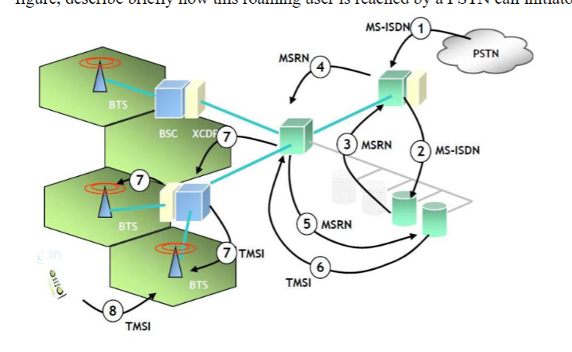

Ans:

In the above given figure, the process for terminating a mobile call for a roaming user in a GSM network is shown. From the figure we can see the following terms as MS-ISDN, MSRN and TMSI.

MS-ISDN: It is abbrivated as ‘Mobile Subscriber ISDN number’ used has the international directory for a given number. This is unique number which can be used for knowing the subscriber's plan in the network. This number can also be used when we need to route calls.

MSRN: It is abbrivated has ‘Mobile Subscriber Roaming Number’ used has a temporary number given to a mobile device who’s on roaming outside his own network area. This number is used instead of MS-ISDN routing the incoming calls to the mobile device when the user is roaming. The MSRN is temporary and can be used during roaming only.

TMSI: It is abbreviated as ‘Temporary Mobile Subscriber Identity’ used to give temporary identifier a to a mobile device by the visited network. This is used for identifying the mobile device visited network for signal. The TMSI is changed regualary for security purpose.

Based on the figure, PSTN call initiator:

1. The PSTN call initiator first dials the MS-ISDN user.

2. The call is then routed to the Home Location Register in the subscriber's home network.

3. The HLR provides the address where the subscriber is currently registered

4. Next call is forwarded to the temporary MSRN of the subscriber.

5. The VMSC queries to get TMSI of the subscriber.

6. Then VLR gives the TMSI to the VMSC.

7. Paging the subscriber using the TMSI is done.

8. The mobile station responds to the paging request and the call is established using the assigned MSRN.